SOL SYDNEY HOBART RACE 2008 SAILING INSTRUCTIONS:
RACE AREA: Tasman Sea, Distance 628Nm approximately, BOATS: Seacart-30 Trimaran Class only.

TIME OF START
Friday, Boxing Day, 26 December 2008, 0200 UTC (1300 hours AEDT (UTC + 11) Australian Eastern Daylight Saving Time)
The Warning Signal will be displayed at 1250 hours AEDT.

The start position is East and outside Sydney Harbour Heads 33.83S 151.30E approximately.
The starting line will be between the mast of the Race Committee signal vessel (a boat displaying a white flag with black ‘CYCA’ lettering, anchored at the eastern end of that starting line) and a large Rolex buoy marking the western limit of that starting line.

COURSE:
Starting from NORTH to SOUTH,
Along the New South Wales, Victoria and Tasmanian coasts,
Passing South of (Mark #2) Tasman Island 43.224S 147.994E to Starboard (See Photos)
Passing South of (Mark #3) Cape Raoul 43.245S 147.994E to Starboard
Across Storm Bay,
Passing South of (Mark #4) Iron Pot 43.046S 147.915E to Starboard
Up the Derwent River to

FINISH:
The finish line will be in the Derwent River, between the flag mast on the finishing box on Battery Point and a Rolex buoy.
The buoy may be fitted with a low power strobe light at night. The buoy will bear 055° true, approximately 300 metres from the finishing box.
When a large yellow inner distance mark is positioned on or near the finish line, boats are required to leave the inner distance mark to port.

NAVIGATION LIGHTS
Boats shall exhibit navigation lights between sunset and sunrise.

CAUTIONS:
All mark positions given are approximate and in the decimal degree format displayed by SOL race client program.

Correct large scale charts must be used.
There are no special fairway marks or obstructions.

PRIZES:
Mount Gay Rum for first “Kiwi” yacht to finish.
Other prizes may be announced.

OTHER SELECTED INFORMATION outside of SOL SI’s.:
See http://www.cyca.com.au/sysfile/downloads/RSHYR08_SI.pdf for Official Roles Sydney Hobart Yacht Race Sailing instructions.

See http://rolexsydneyhobart.com/ for Yacht Tracker and race details.

The actual start will be on TV and Internet feed for 90 minutes, Therefore the starting signals and other information is included for your enjoyment.
Following earlier disasters, the Radio and Safety information, checklists and schedule details are worth reading.

PRIZE GIVING:
The line honours trophy will be presented to the line honours boat on arrival at Constitution Dock in Hobart.
The overall winner, second and third overall and divisional winners will be announced at a dockside presentation after boats arrive.
Details will be provided to boats in Hobart.

The formal presentation of trophies and prizes will take place at 1100 hours on 1 January 2009 at the Royal Yacht Club of Tasmania.

7. RESPONSIBILITY
7.1 Responsibility
All those taking part in the race do so at their own risk and responsibility. The Organising Authority, Rolex SA and their respective officers, employees, volunteers and members, accept no liability for any injury, loss or damage that may be suffered by any competitor, and any liability for harm to persons that results from breach of an express or implied warranty that the Rolex Sydney Hobart Yacht Race and all services relating thereto will be conducted or
rendered with reasonable care and skill is excluded.
Specific attention is drawn to RRS Fundamental Rule 4, which states: "The responsibility for a boat's decision to participate in a race or to
continue racing is hers alone"

7.2 International Convention for the Safety of Life at Sea
It is accepted as the normal practice of seamen, indeed there is an obligation upon masters, that they render every assistance within their power in cases
where a person or persons are in distress at sea. These obligations are set out in regulation V/10 of the International Convention for the Safety of
Life at Sea, 1974 (SOLAS 1974).

7.3 International Aeronautical and Maritime Search and Rescue Manual Vol. III
A boat is required to comply with International Aeronautical and Maritime Search and Rescue Manual Vol. III upon receiving a Distress Call The Immediate Action required by IAMSAR VIII is:
(a) Acknowledge receipt and, if appropriate, re-transmit the distress message;
(b) Take an immediate magnetic compass bearing to the boat in distress (if practicable);
(c) Communicate the following information to the boat in distress:
(i) Identity
(ii) Position
(iii) Estimated Time of Arrival (E.T.A.);
(iv) When available, magnetic bearing to the boat in distress;
(d) Maintain a continuous listening watch on distress frequencies;
(e) Post extra lookout if in the vicinity;
and
(f) Relay Distress Message to coastal station and rescue coordination control and update as necessary.

16.1 Backstay flag
A special Rolex Backstay Flag, provided to each boat at or prior to the race briefing, shall be flown at a height of 2 metres from the working deck on the backstay or port/starboard mizzen shroud of each boat from the time the boat approaches the manoeuvring area until the boat finishes the race.

16.2 Battle flag
The Rolex Battle Flag, provided to each boat at or prior to the race briefing, shall be flown from 0700 hours on 26 December 2008 until 1200 hours on 1
January 2009, except whilst the boat is racing.

16.3 Other flags
Except for RRS 44.3 or 61.1 and National Flags, Club Flags, Start Line Flags or Race Flags, NO OTHER FLAG shall be displayed by a boat after the
Warning Signal until the boat finishes.

16.4 Bow decals
Bow decals supplied by the Organising Authority shall be displayed by each boat as supplied and in the manner required by the Organising Authority from 0700 hours on 26 December 2008 until 1200 hours on 1 January 2009.

17. REPORTING AT START
17.1 Boats intending to start shall report to the race officials on the Race Committee vessel (a boat displaying a white flag with black ‘CYCA’ lettering at the western end of the southern start line). The boat shall have its trisail and storm jib set until acknowledged by race officials. The boat shall hail its sail number and the number of persons on board until acknowledged by race officials aboard the committee vessel.

17.2 A boat that is delayed may start within the start time limit (refer SI 18.4 and 26.1). The committee vessel will remain on station on the start line until all boats have started or the starting time limit has expired, whichever occurs first.

17.3 The radio relay vessel “JBW” will be available for radio checks on 26 December 2008 between 1130 hours and 1230 hours on race frequency
6516kHz.

19. START SIGNALS
19.1 Visual signals will be made from the respective committee vessel as described in SI 18.1. Sound signals may be made by a cannon situated on a VIP
Vessel situated to the North of the northern start line. An air horn will be used if the cannon misfires.

19.2 The start signals will be as per RRS 26 (as amended) with five minute intervals, with the inclusion of a one-minute signal. The Class Flag will be International Code Flag “W” (amends RRS 26).

19.3 Warning Signal: Ten minutes before the start of the race the Class Flag will be displayed and a sound signal will be made.

19.4 Preparatory Signal: Five minutes before the start of the race International Code Flag “P” will be displayed and a sound signal will be made.

19.5 One Minute Signal: One minute before the start of the race International Code Flag “I” will be displayed and a sound signal will be made from the respective race committee vessel.

19.6 Starting Signal: At the start time both the Warning, Preparatory and One Minute Signals will be lowered and a sound signal will be made.

20.4 THERE WILL BE NO GENERAL RECALL.

24.2 Boats finishing at night are required to illuminate their sail number on the port side.
Note 1: After finishing, boats shall heave-to and await the arrival of an escort vessel. Boats to be berthed in Constitution Dock shall have an anchor ready and
shall observe the instructions of the escort vessel.
Note 2: All competitors are required to follow any instruction from the Hobart Harbour Master.
Note 3: The Melbourne to Hobart Race fleet will be using the same finishing line.

PYROTECHNICS STORAGE
Immediately each boat is berthed in Hobart all of the pyrotechnic devices (flares, rockets, etc) shall be stowed and securely locked in a container (fixed or
portable), the key to which will be held in the custody of the skipper for the duration of the boat's stay.
(THIS IS A TASMANIAN PORTS CORPORATION REGULATION)

SYDNEY HOBART RACE RECORDS

LOA | Boat | Owner | Class | Elapsed Time
Open | Wild Oats XI  (2005) | R Oatley | 30m Maxi | 1d 18h 40m 10s
Conventionally  Ballasted | Brindabella  (1999) | G Snow | Jutson 72 | 1d 20h 46m 33s
< 18.5m | Magna Data  (1999) | S Langman | Open 60 | 2d 1h 37m 21s
< 15.5m | Yendys  (1999) | G Ross | Farr 49 | 2d 7h 57m 30s
< 12.5m | Leroy Brown  (1999) | W Wieckman | Farr 40 OD | 2d 11h 24m 50s
< 11.0m | Pied Piper  (1975) | R Turner | Peterson 36 | 3d 7h 38m 58s
< 9.5m | Toecutter  (2002) | R Hick | Hick 31 | 3d 9h 19m 00s



Tasman Island Light, Tasmania.

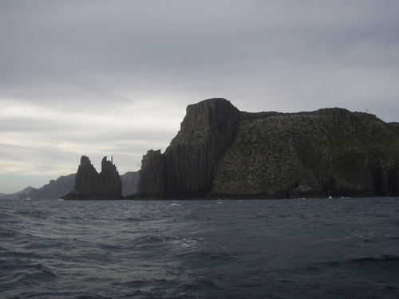

Tasman Island with Cape Raoul in distance, entrance to Storm Bay, Tasmania.

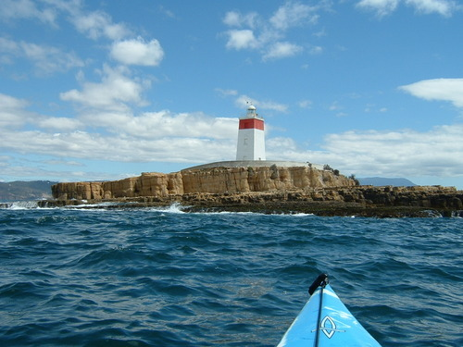

Iron Pot Lighthouse, marking the entrance to Derwent River, Tasmania.

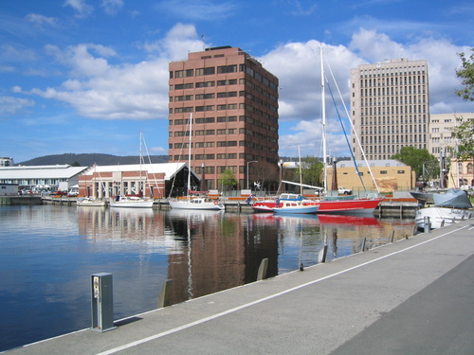

Constitution Dock, Hobart, Tasmania, awaiting fleets arrival.

