Hello,
I just 4 points to make:
• This is the Phare de Cordouan and not Courdoyon
• I would like that the door be kept north of the island of Ré, leaving the choice of passing to the west or east of this island (Phare des Baleines)
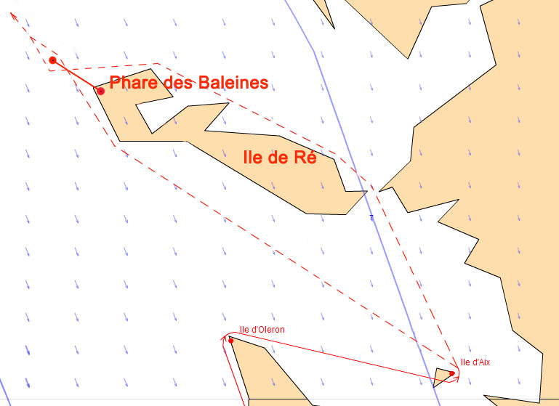

• I think it is better to go north of Brenec island rather than South
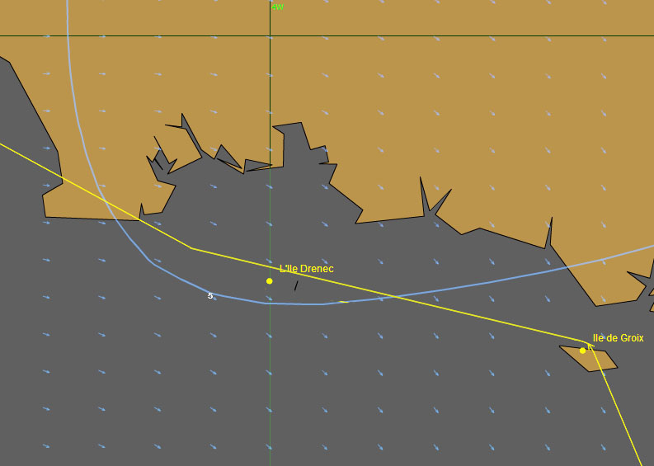

• I think that the arrival at Brest would be better as I put on the plan attached
