Sailplanner can use brainaid’s NMEA proxy.

I figured out a roundabout way to get Sailplanner to use brainaids NMEA proxy. Currently brainaids NMEA proxy can only be used by navigational software that supports NMEA through the TCP/UDP protocol. Sailplanner supports NMEA but through a serial port connection (COM1, COM2 ...) You have to download and install two additional software programs both are free. First download PolarCOM from www.polarnavy.com, the other program needed is Virtual Serial Port Emulator (VSPE)from http://www.eterlogic.com/Products.VSPE.html scroll to the bottom of the page and hit the download button (this is the FREE 32 bit version).

Step 1 Install VSPE and launch it, you should see the following window. Click on the Device menu then click create

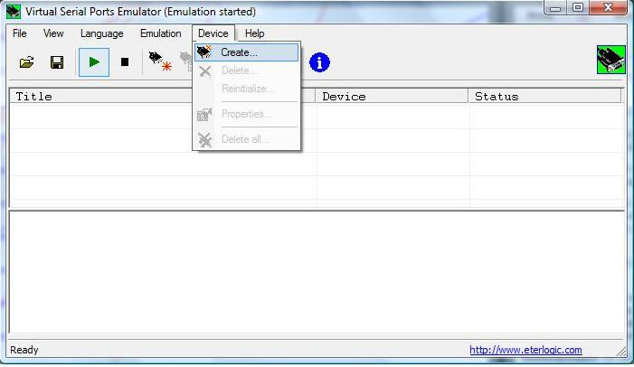

Step 2 On the Specify Device Type window select Splitter then click NEXT

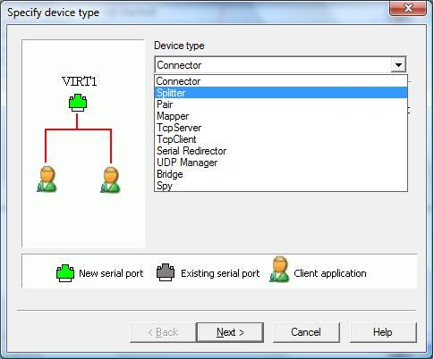

Step 3 On the Specify Device Characteristics Window select your data source port (COM3 was the only one available in my case), then select a virtual serial port (I chose COM1).

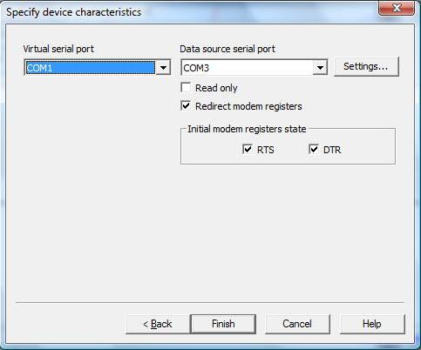

Step 4 You should now have a window with a COM3->COM1 Splitter device Status n/a. Now click the green triangle (arrow or play button).

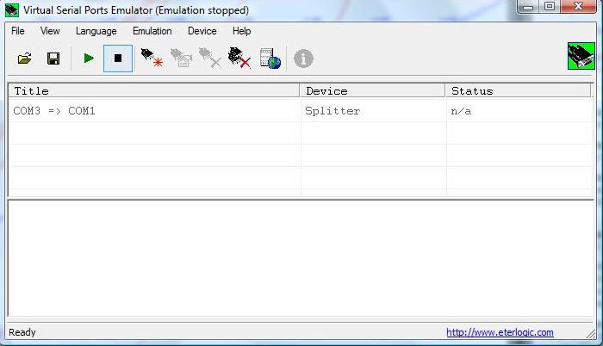

Step 5 If all goes well you should now have a window that shows Status ready with an initialization Ok message. Click the MINIMIZE button DO NOT CLICK the CLOSE button. The window will now go to the tray (lower right hand corner of your screen with a little serial port plug icon).

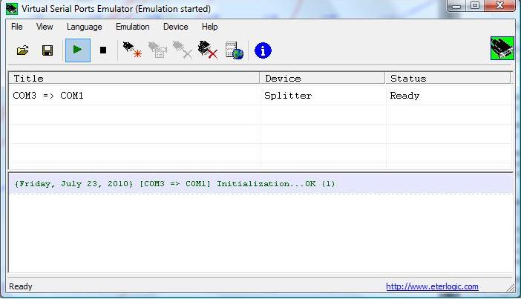
Step 6 Install PolarCOM. Do not launch PolarCOM yet, first go to brainaids site http://sol.brainaid.de/sailonline/toolbox/ and log in to the race of your choosing. Now click on the Navigation button. There will be an icon for brainaids NMEA TCP proxy, click on it.

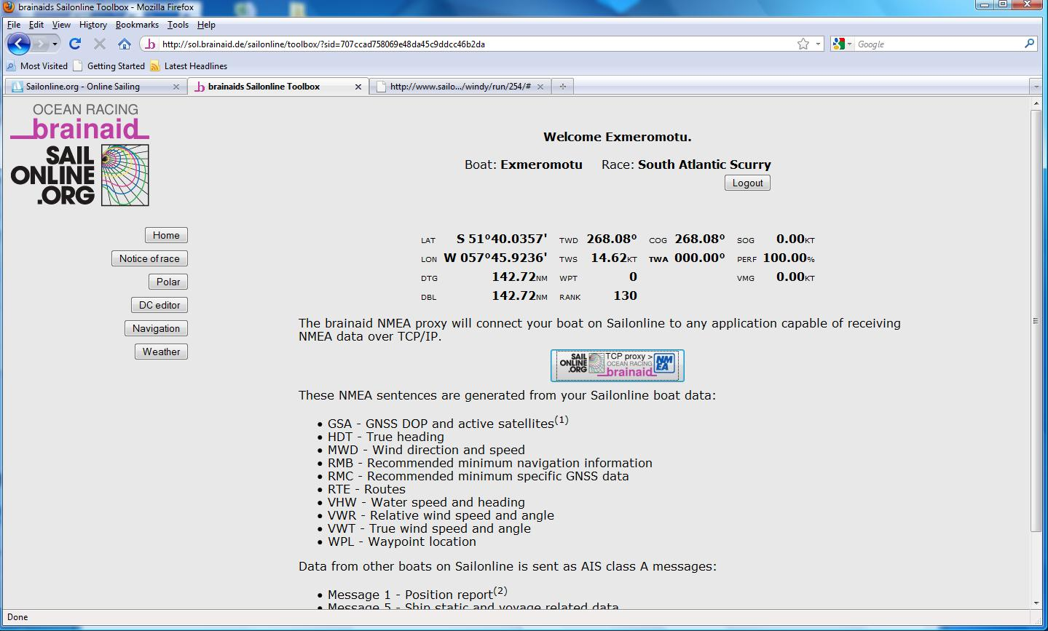

A Java window will show up (Step 6A) asking you to log in again, enter your password and Login. Write down the IP address (192.168.1.102 in my case) and the port number (5010).

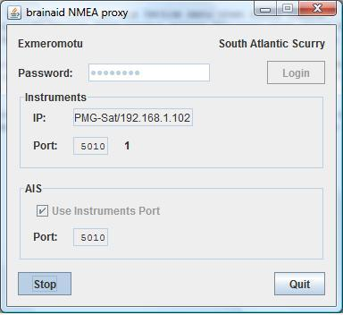

Step 7 Now we can launch PolarCOM. A default set of instruments will show up un your screen. We now need to configure them by either right clicking on the instrument panel or right clicking the PolarCOM icon at bottom right hand side of your screen.

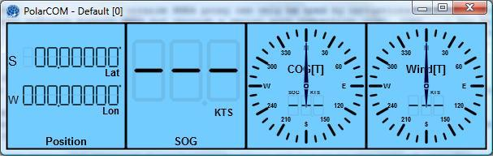
A PolarCOM configuration window will pop up (Step 7A) with an ID 0 (Default) setup.

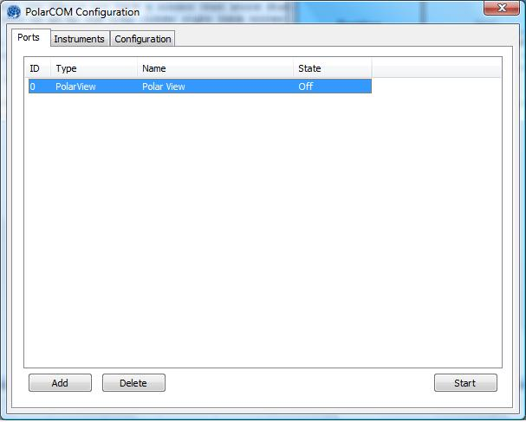

Double click on this default setup to open it, a Add Port window will pop up(Step 7B), enter whatever visible name you want, your IP address for brainaids TCP proxy (192.168.1.102 in my case) and the port number (5010) in my case. Make sure the input check box is marked, click activate on startup and click apply.

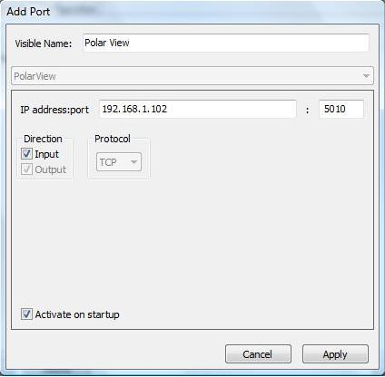
The window will close. Now on the PolarCOM configuration window select the ID O port (the one you just created) and click START. The state of the port should change from OFF to RUNNING

Step 8 Ok now on the PolarCOM configuration window click Add. A new Add Port window will show up. Enter whatever visible name you want. then choose NETWORK CLIENT (from the options just below Visible Name)and again enter your IP address and Port. Make sure both Input and Output are selected and that the protocol is TCP, select activate on startup and then click APPLY.

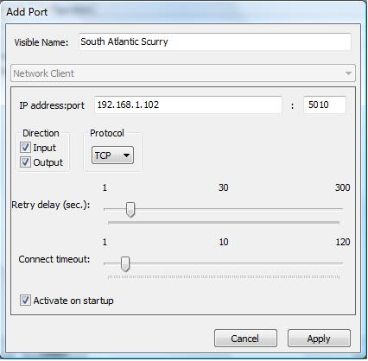

Your PolarCOM window should now look like this.(Step 8A)

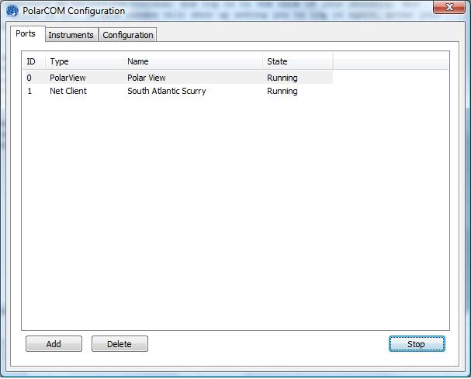

Once you activate the ID 1 port your default PolarCOM instruments should start displaying data. (Step 8B)

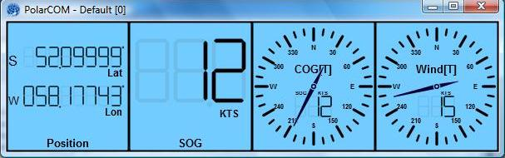

Now we need to add 1 more port, a serial one so that Sailplanner can connect to the data stream.

Step 9 Once again click add on the PolarCOM Configuration window. Enter whatever visible name you want, the connection is now Serial Port, and the COM port should be your VIRTUAL port on the VSPE splitter (COM1 in my case.) Make sure input and output are selected, the speed I chose 19200 that seemed to work best but you can always go back and fine tune it. Leave all other settings as default and select apply on startup.

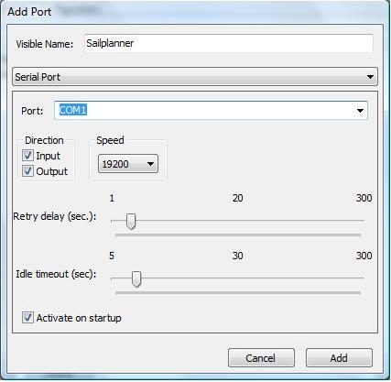

Your final add port window should look something like the pic above now click ADD.

You should now have 3 ports running on the PolarCOM configuration window

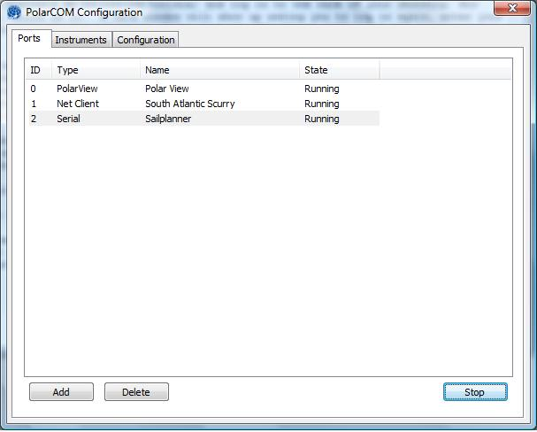

Step 10 Now open up Sailplanner, on the Boat Panel select lock to NMEA, an NMEA setup window opens up. Select the COM port you assigned as VIRTUAL (COM1 in my case), has to be the same COM port you assigned on PolarCOM too. The port speed you assigned on PolarCOM should be the same as the one on Sailplanner (19200 in my case). The type should be NMEA.

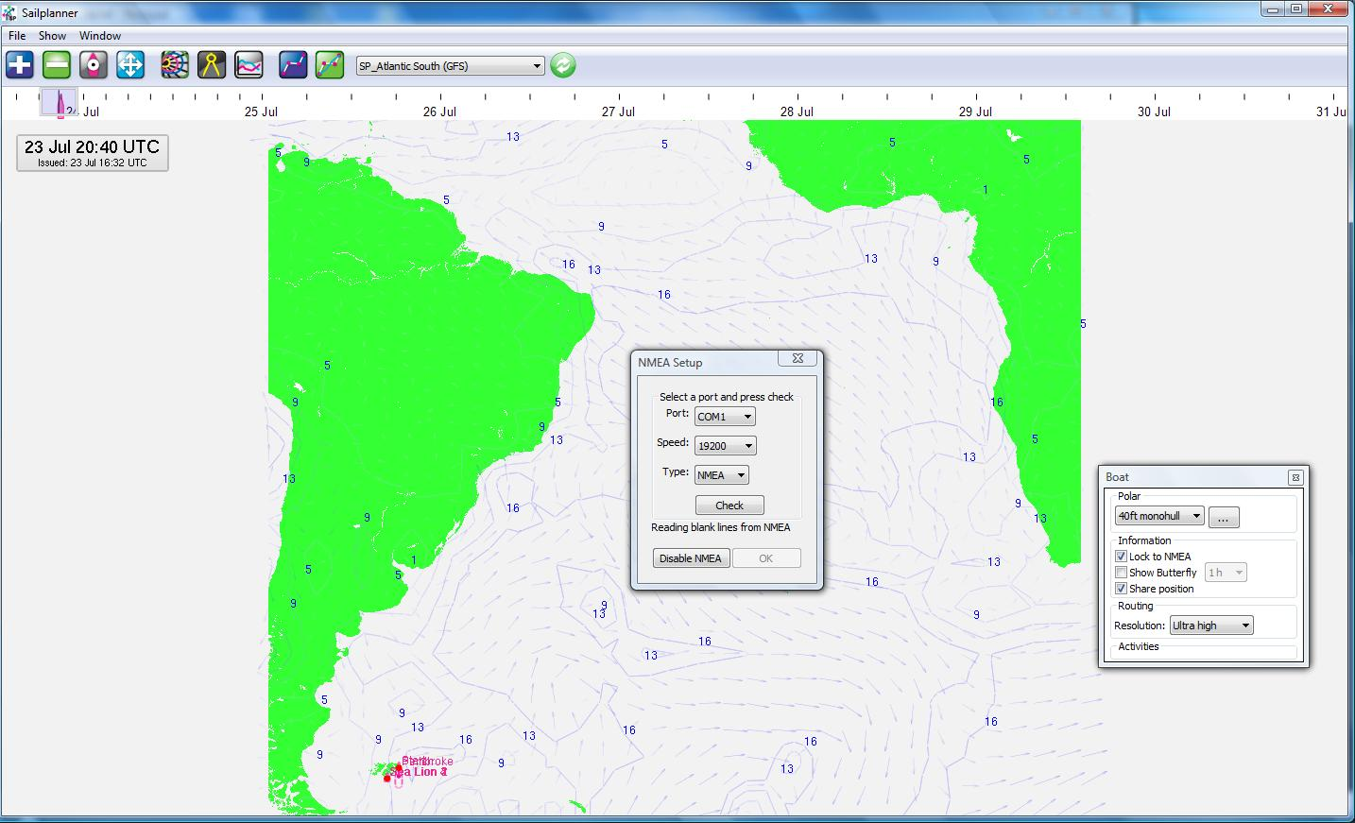

Now comes the moment of truth, click Check. If everything goes according to plan you'll get an NMEA OK message (Step 10A). Success!!

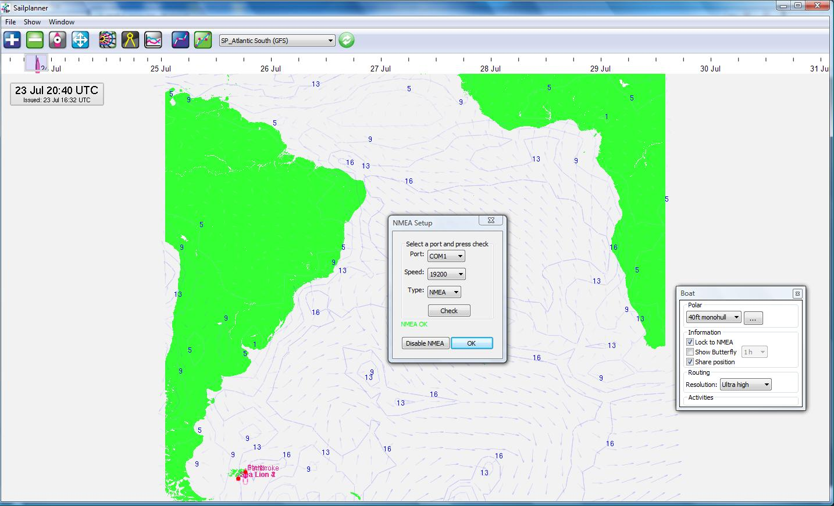

Now click OK and enjoy your SOL boat info (don’t forget to select the instruments window on the Window menu) and position in real time on Sailplanner (Step 10B)!!

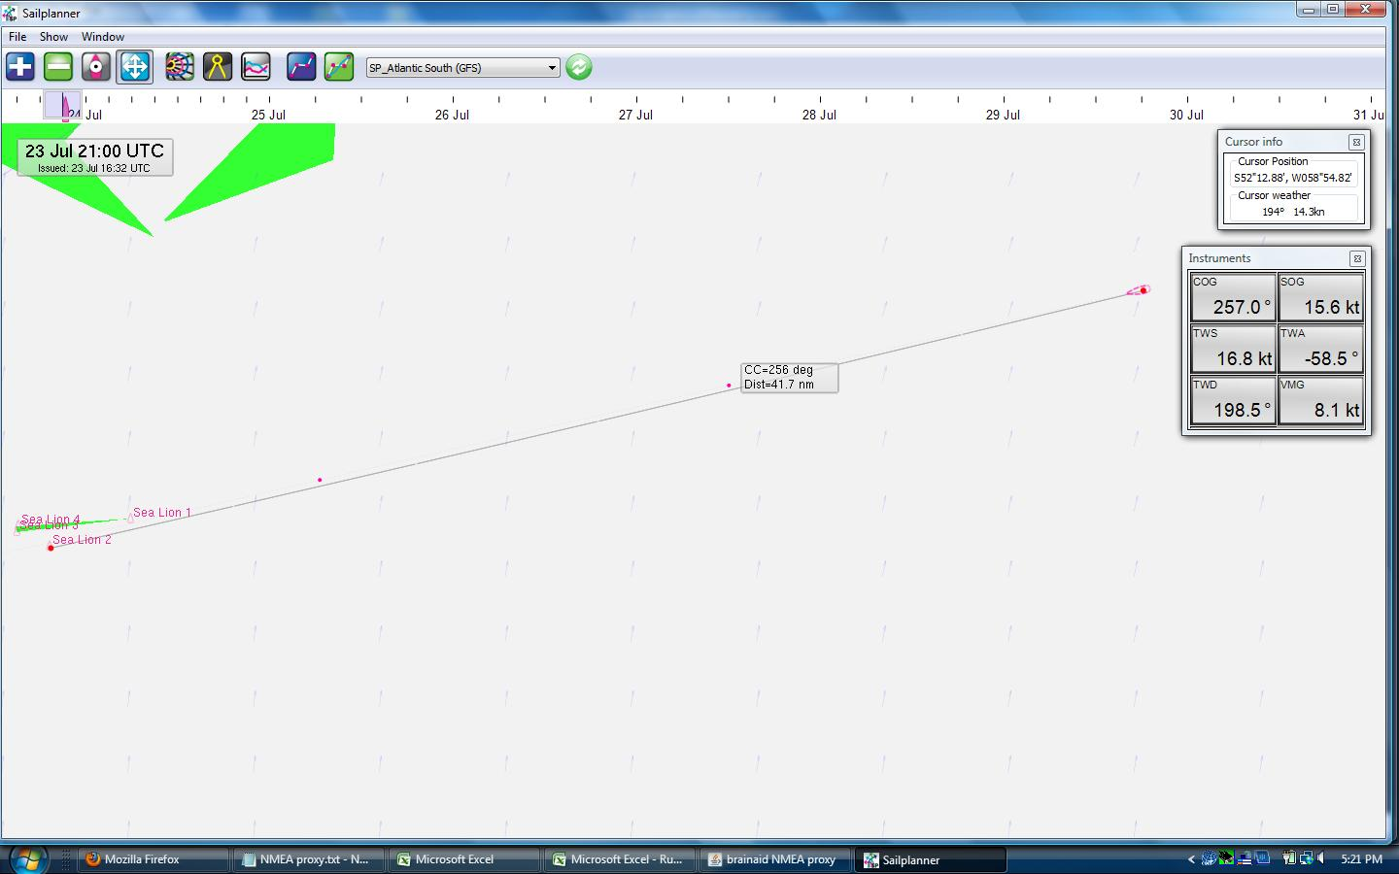

I know there must be a more "elegant solution" to get SOL's NMEA data stream into Sailplanner, but this is what worked for me so far. I'm no communications guru either, if anyone has a simpler solution please share it. As soon as I figure out how to do the COM splitter trick on a Macintosh I'll post it. Should anyone have any question please email me exmeromotu_@hotmail.com I’ll be more than happy to answer them.

Cheers!!

