January 2008
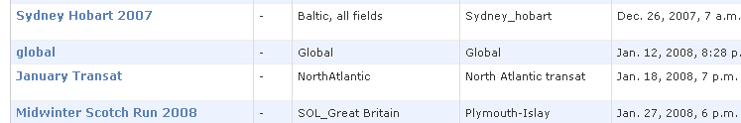

January 2009
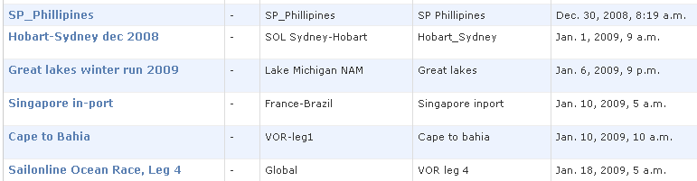
January 2010
