FEBRUARY
2008
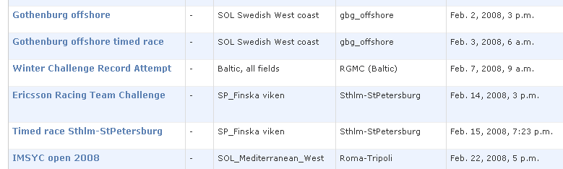
2009
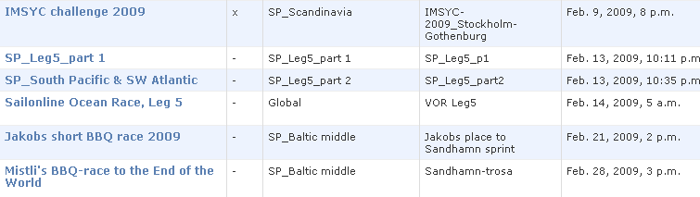
2010
