Configuring Sail Planner

I have been trying to get my laptop to run SailPlanner for Sailonline races but have been having limited success locking my boat position to its reported GPS position. I was inspired to attempt this by Exmeromotu’s original guide elsewhere in this forum which enabled me to achieve things that I would previously have not believed possible. See http://sailonline.org/board/thread/4342/sailplanner-users-can-connect-to-brainai/?page=1#post-4342

With the original guide I was quickly able to get other applications to read the GPS position of my boat and display AIS positions of other boats – but until today Sail Planner has refused to connect.

The breakthrough for me was to use a different virtual serial port device – Jeroen suggested use of GPS Gate. However, until now I had had most success with NavmonPC and that incorporates GPS Gate – so I looked around for something else that might fit the bill and found HW Virtual Serial Port at
http://www.hw-group.com/products/hw_vsp/hw_vsp2_en.html
Note that the above link is to an older version of the HW Virtual Serial Port (Version 2.5.10.)

A later version HW VSP3, which I have not tried is available here:
http://www.hw-group.com/products/hw_vsp/index_en.html#licence

Here is a set of screenshots that show my config for each of the key applications:

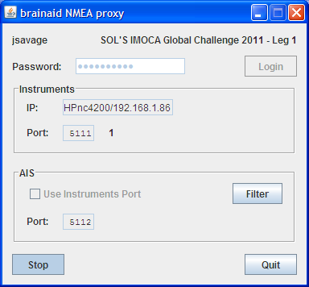

To make the Brainaid Proxy available as a Com Port I used the non-current version of HW Virtual Serial Port. The current version may work too but this version seemed smaller and since it has less functionality I thought it might be simpler to get working.

It was a piece of cake – with one exception…

The IP Address that was detected was 192.168.0.1 which is my routers address. My Brainaid proxy is running on my local machine which is 127.0.0.1 or 192.168.0.86 as shown below. I also entered the Port to the number that I had set Brainaid Proxy to use – 5111. I don’t know what the purpose of the Server Port box – I don’t think it is important as I left that at 23 and it worked fine. I simply made the above changes and pressed the button “Create Com” . The Ethernet Status area immediately started showing that data was being received.

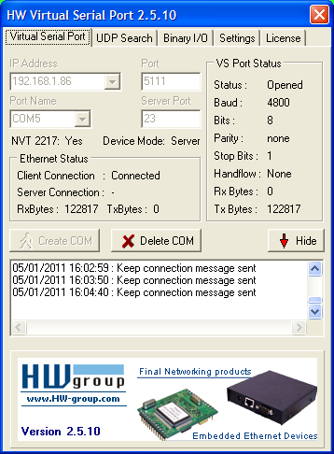

I then launched Sail Planner and locked the boat to NMEA on COM 5 in the Boat panel.

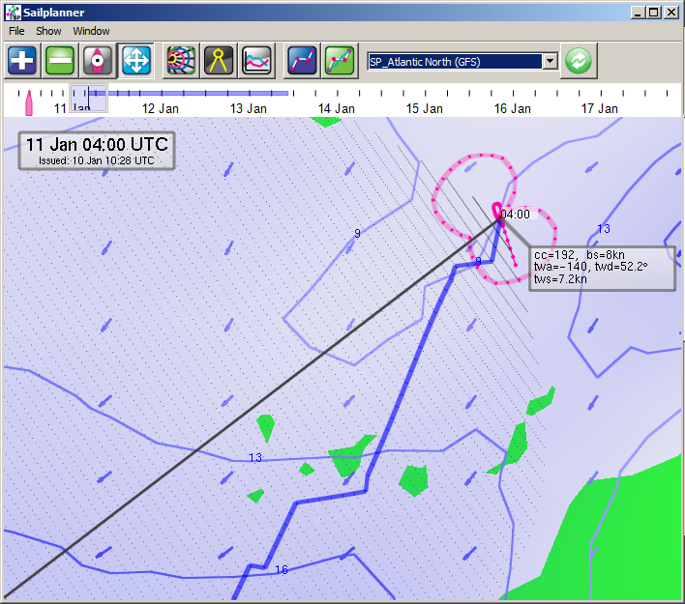

Good luck – I hope this helps someone

Now I need to learn how to use this thing intelligently…

James

