MAY RACES FROM PREVIOUS YEARS
MAY 2008
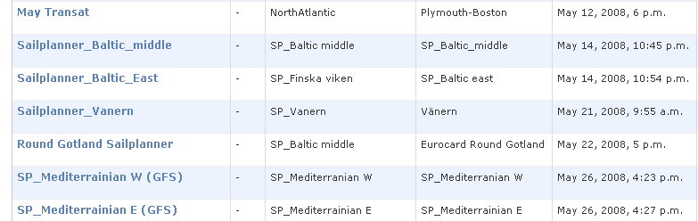

MAY 2009
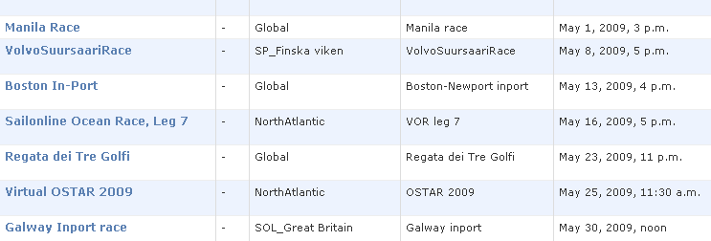
MAY 2010
