JULY RACES IN PREVIOUS YEARS
JULY 2008
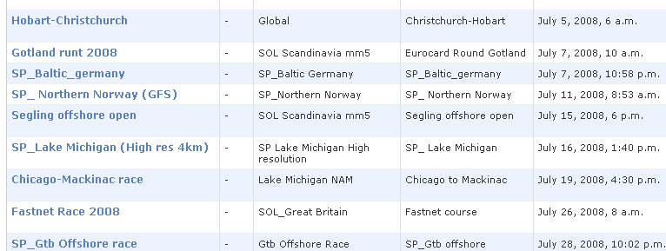

JULY 2009
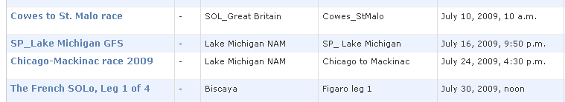

JULY 2010
