JULY RACES IN PREVIOUS YEARS

JULY 2008
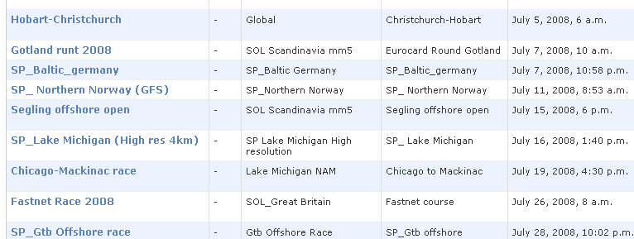

JULY 2009
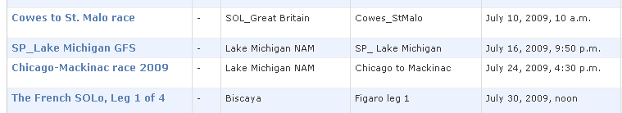

JULY 2010
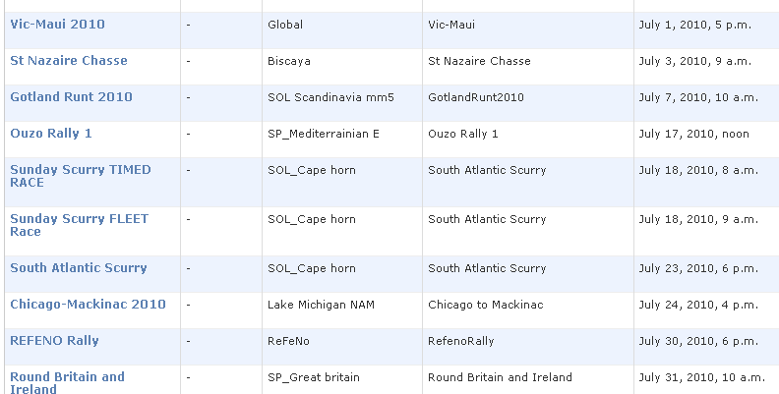
JULY 2011
