APRIL RACES IN PREVIOUS YEARS
APRIL 2008
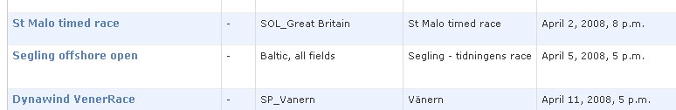

APRIL 2009
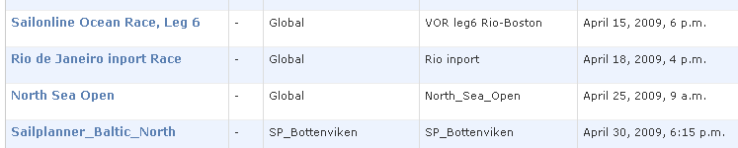

APRIL 2010
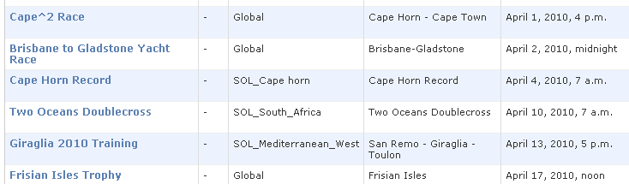
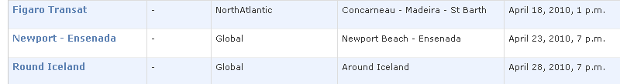
APRIL 2011
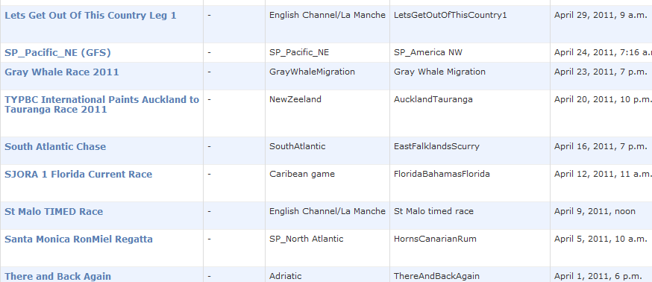
2012
