MAY RACES FROM PREVIOUS YEARS

MAY 2008
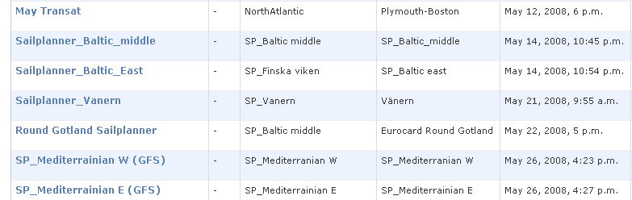

MAY 2009
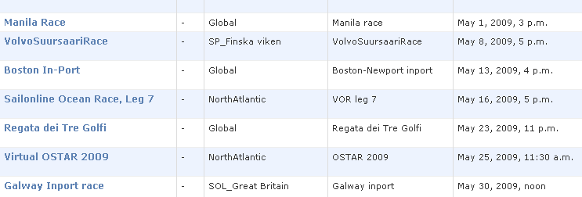

MAY 2010
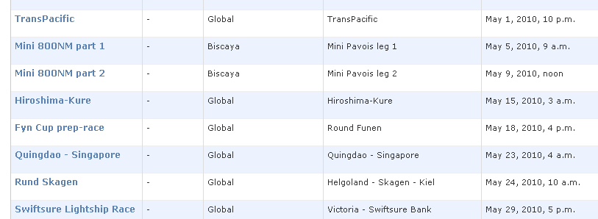
MAY 2011
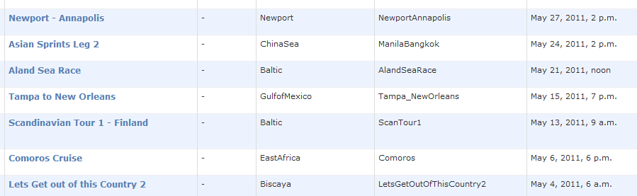
2012
