JUNE RACES FROMPREVIOUS YEARS
JUNE 2008
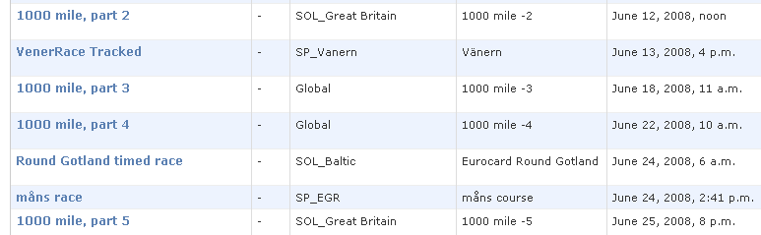
JUNE 2009
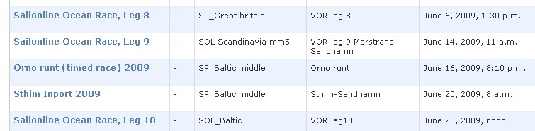
JUNE 2010
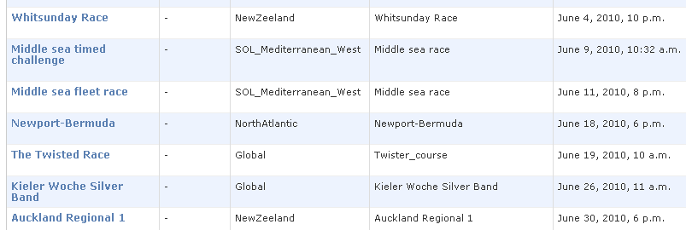
JUNE 2011
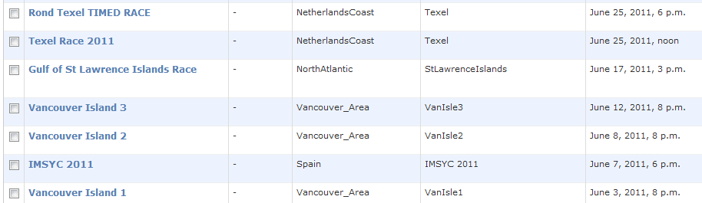
2012
