SOL Wx Inspector HTML locally
1) Extract (unzip) WxInspector folder wherever you want (e.g. Desktop). You can create Shortcut to containing HTML file .
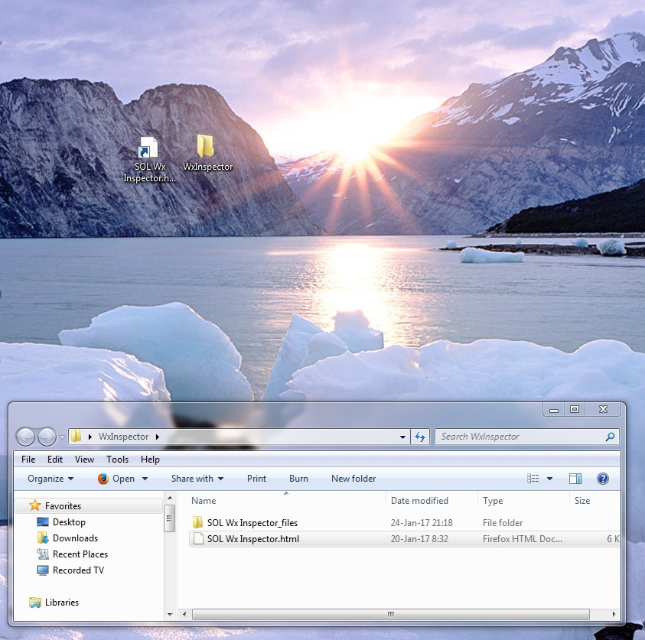
2) Double click file or shortcut to open in your default browser (here is Mozzila Firefox). Then right click in the field to open Adobe Flash Global Settings...
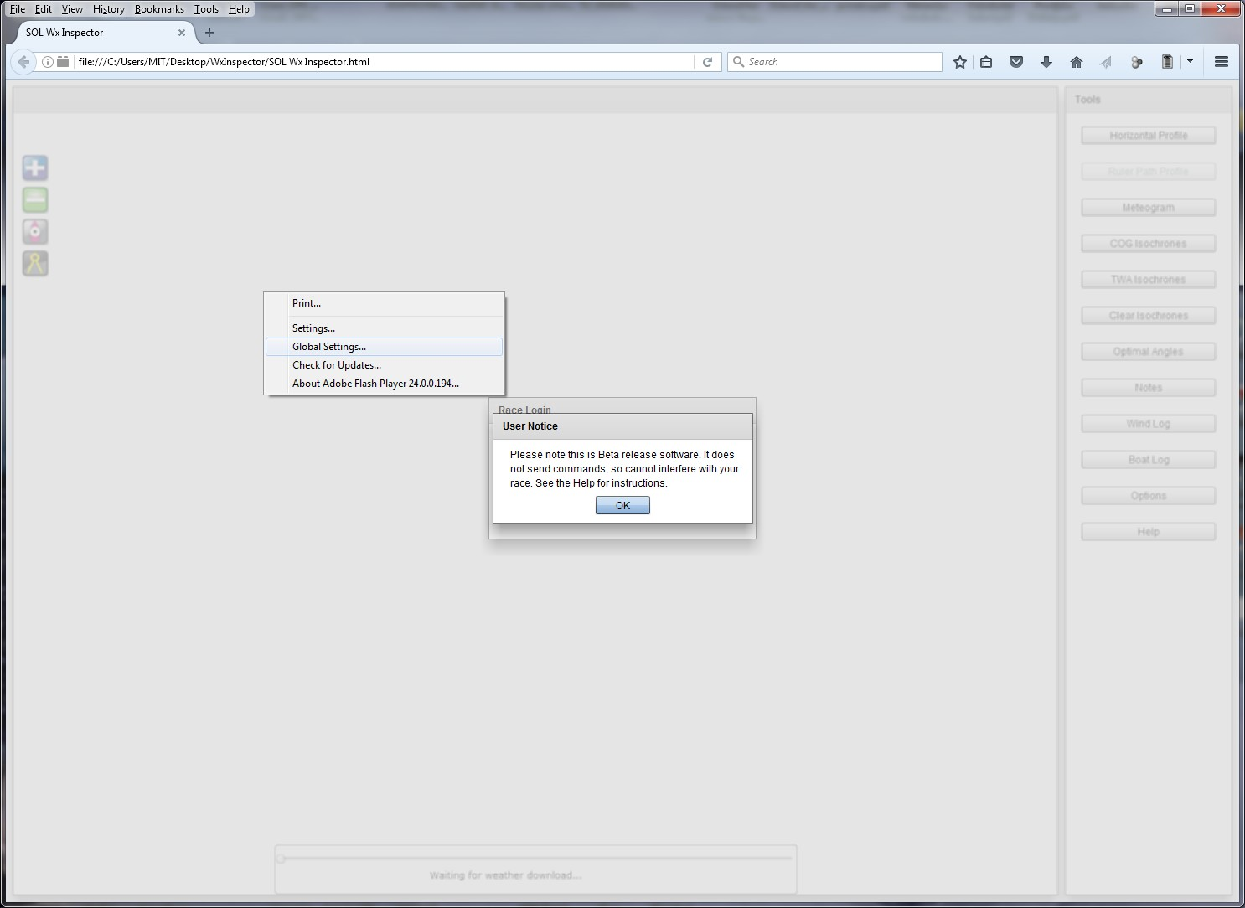
3) In Advanced Tab open Trusted Location Settings... -> Add.. -> Add Folder... and browse for WxInspector folder.
Select it, Ok -> Confirm and close all Flash windows.
NOTE: In Chrome browser, browsing for folder and selection in Adobe Flash Global Settings... doesn't work! You must type full path in
Global Security Settings panel -> Edit locations -> Trust this location for WxInspector folder. Something like: file:///C:\Users\<USER>\Desktop\WxInspector
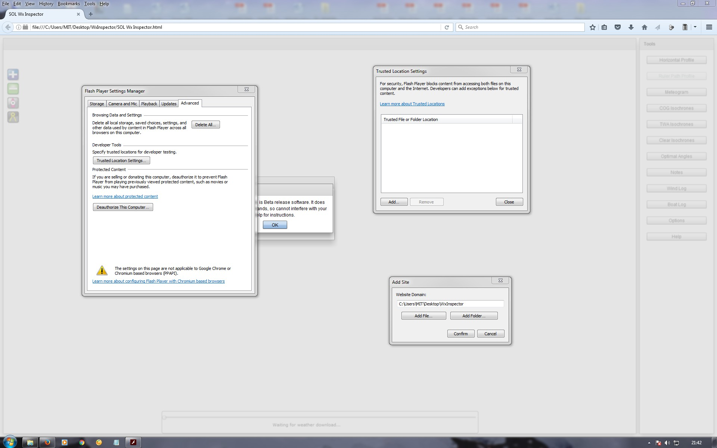
4) Reload page and you should have working SOL Wx Inspector! :-D
If asked, allow page to store content localy.
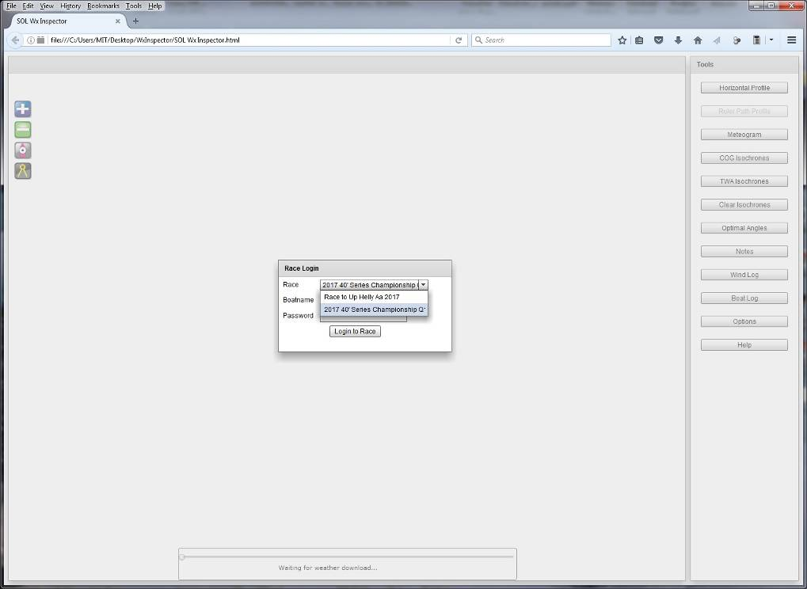
Use it wisely!
FW all!
(This all work in Win7. For Win10, Linux etc. I don't know)

