Once you have registered in a SOL race, go to http://sol.brainaid.de/sailonline/toolbox/ and log in to that race with your normal SOL name and password. Then go to the Navigation tab and…
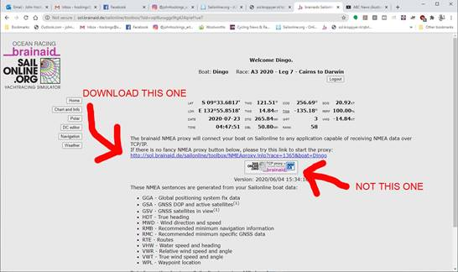

Once you have it downloaded, run it..
you should get these windows next...
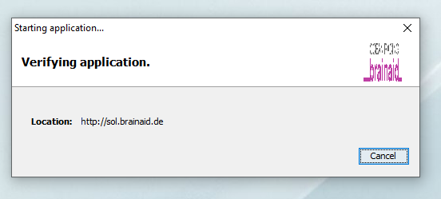

and then this log in screen..
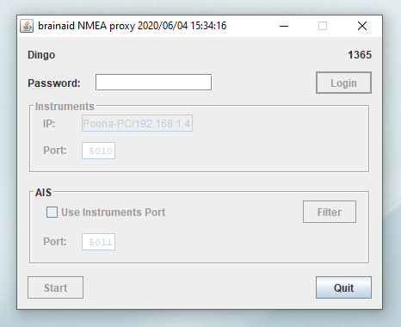

Insert password and click login..which takes you to...
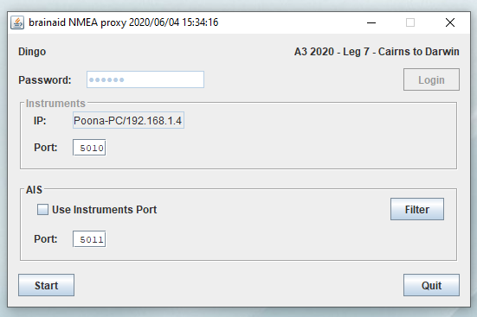

Check port is 5010 or whatever number you want to use, ignore AIS for now, and click start. Then we go over to QtVlm

When it opens, use ‘Real’ boat. Once you have it running, go to the configuration tab.

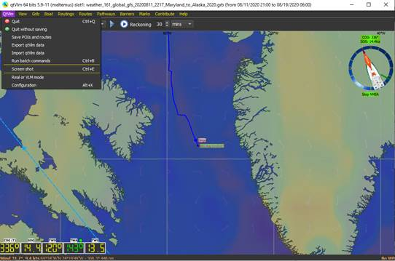

It should be filled in like this.....
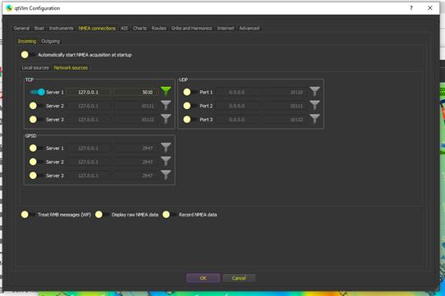

Whilst in the Configuration area, then go to the Advanced tab and click SOL..
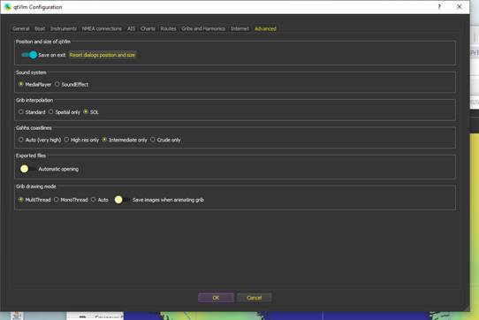

Then press ok, before leaving config, or you will not save these entries.

Once back on the main qt screen, go to Boat tab, Boat Settings...
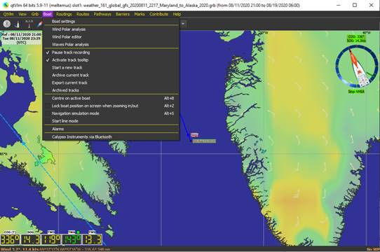

You need to Import the correct polar, from Brainaid again, here....
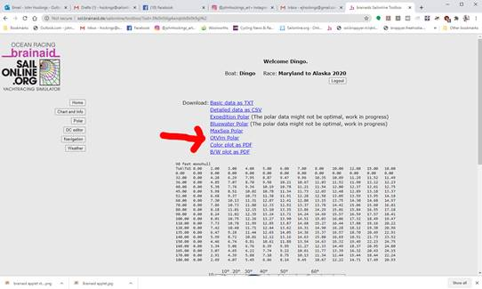

Now, on the Boat tab, click polar, and import it from wherever you downloaded it to from Brainaid....
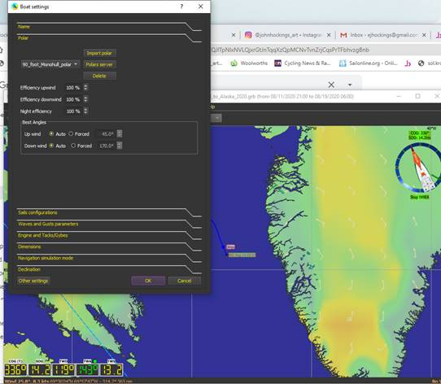

Now you can return to the QtVlm main screen, and we'll load the grib, which comes from the Brainaid Weather tab....
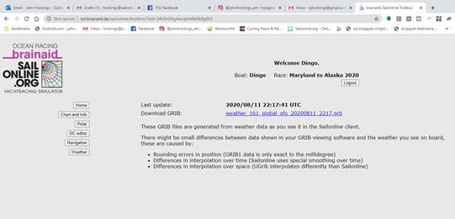

Load it into QtVlm here, by pressing Open, and navigating to your downloaded weather file....
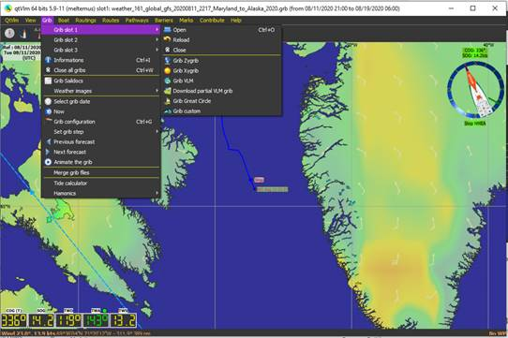

Now you need to connect QtVlm to the nmea source by clicking 'start nmea' here....
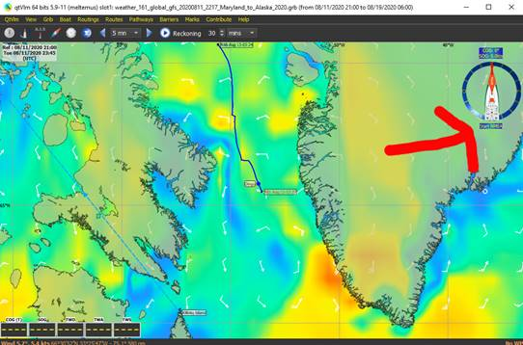

You should now be connected. Go to boat tab in QtVlm and click Centre on active boat. Hopefully you will now be viewing your boat moving in the right position on the QtVlm chart.

Now you need some waypoints. You can download the gpx file from the new html5 client here...
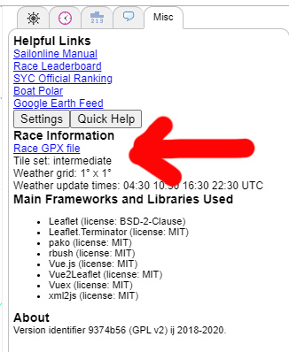
and you can open it in QtVlm here....
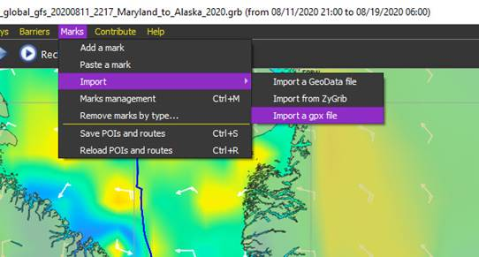

Next you do a routing, from your boat, to the next mark, or whatever other mark you might like to insert...
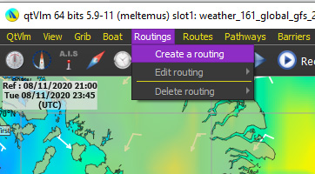

which takes you to...where you can choose your 4 inputs and then click OK
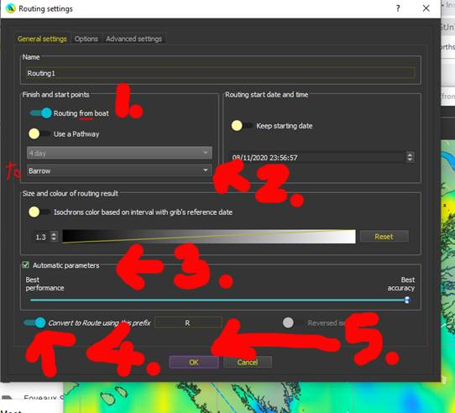

You will end up with a coloured route on your QtVlm chart, looking something like this, and a dialog box like this...which you tick and OK as shown....
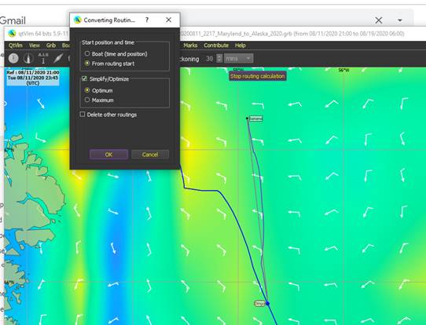

Then you will get this ....and you click optimize..
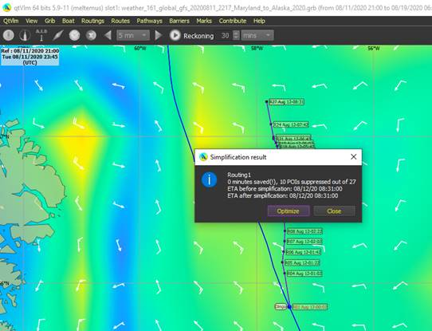

which gives you....and you click OK.
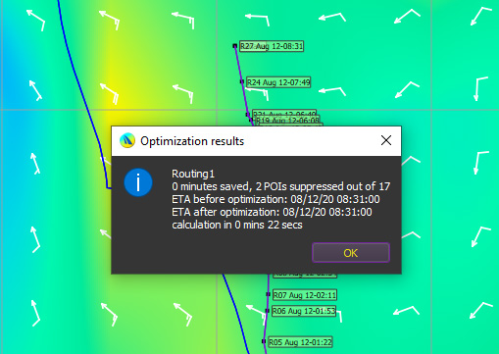

Then you need to get the DCs out of this. So you right click on the route..
and you get this, so click Edit Route 1..
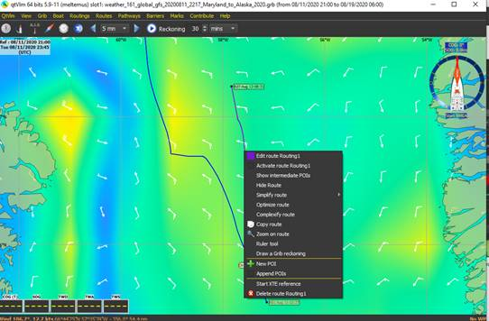

which brings you to this window....where you want the Route Logbook tab, and you click Export csv. Save it where you want it.

Then go to http://sol.kroppyer.nl/qtvlm2dc/ where you can open that saved csv file and convert it to DCs, Copy and paste those you want (cc or twa, or a combination of both) into Brainaid DC window.

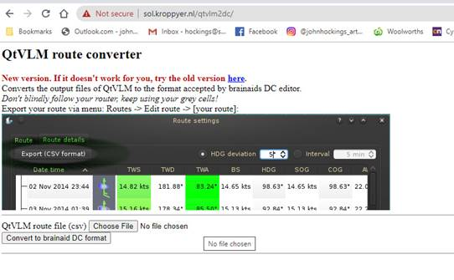

and...
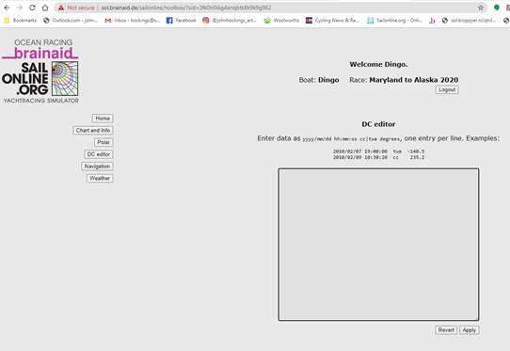
Paste your copied DCs into the window of the Brainaid DC Editor and then click Apply. It will transfer them into the SOL DC box, and you're all set to go! :)

